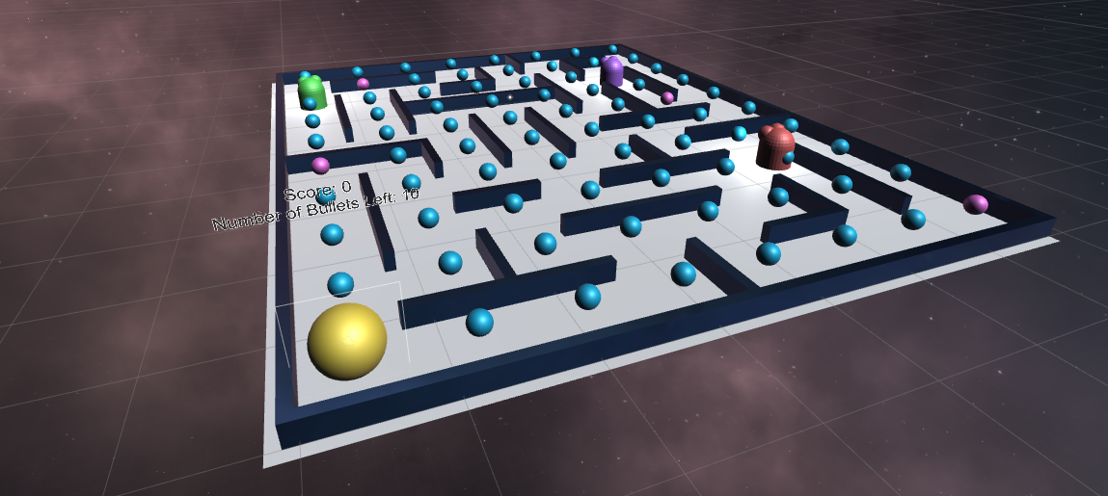

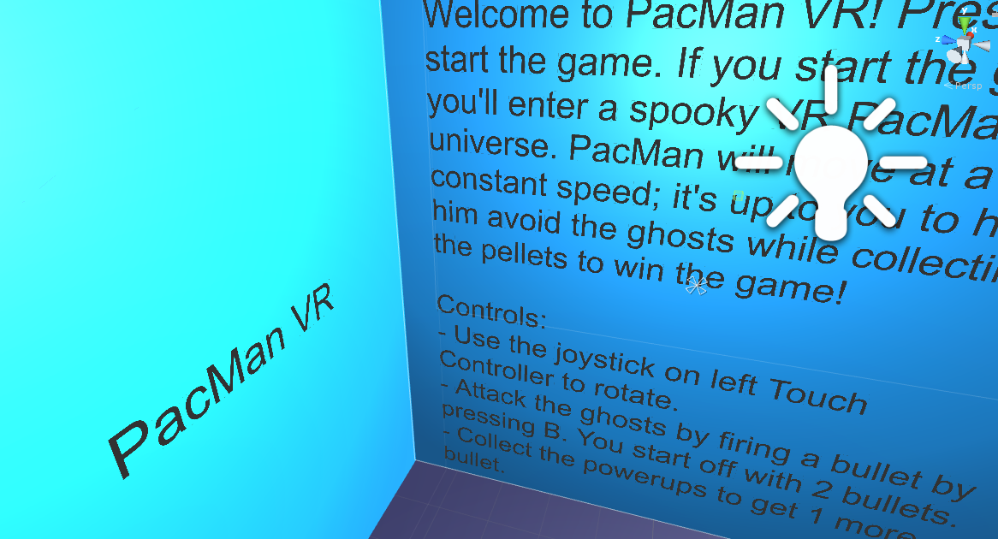

Title: Pac-Man VR

Group: Dongze Lu (dlu13), Annabelle Shih (ayshih2), Saba Imran (simran5), Noah Lee (nylee2) (Group 21)

Description: This game is an immersive, virtual reality representation of the popular Pac-Man arcade game from the 1980s. To play our version, you will act as the Pac-Man avatar moving through a maze universe. The goal is to collect all the pellets before being destroyed by a ghost! If you collide with a ghost, you lose. You will also have a limited number of bullets that you can use to kill off the ghosts by pressing B. You can also press the A button to use a pause menu. Good luck!